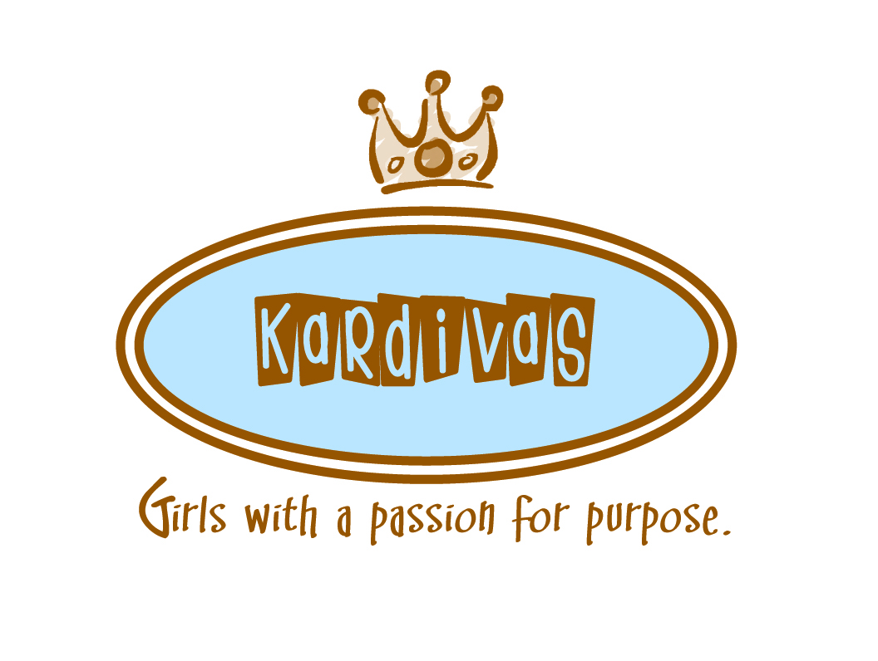

Join us for a Kick-Off “Get to Know You” Party  
***Moms and Daughters are both invited!***  
Thursday, September 27  
2:50pm-4:00pm  
BCE Library

Ice cream sundaes -- Fun activities -- Registration Details

*Questions?* Contact [gingernelson@gmail.com](mailto:gingernelson@gmail.com) or meniles@gmail.com

Inviting all 5th grade girls!

KARDIVAS is a character and friendship club for 5th grade girls that will meet each Thursday, from 2:50 - 4:00pm at BCE.   
Club time will include a snack, games, interactive lessons, special speakers, service projects, and social events.   
***The BEST part: It’s led by high school/college mentor teen girls.***  
Fun and Friendship are ***guaranteed***!  
***Registration is open online at*** [***eanes.augusoft.net***](http://eanes.augusoft.net/) ***$60/semester includes T-shirt, snacks, and activities***